FN: ________________________________  Group: ____________

Date: ______________

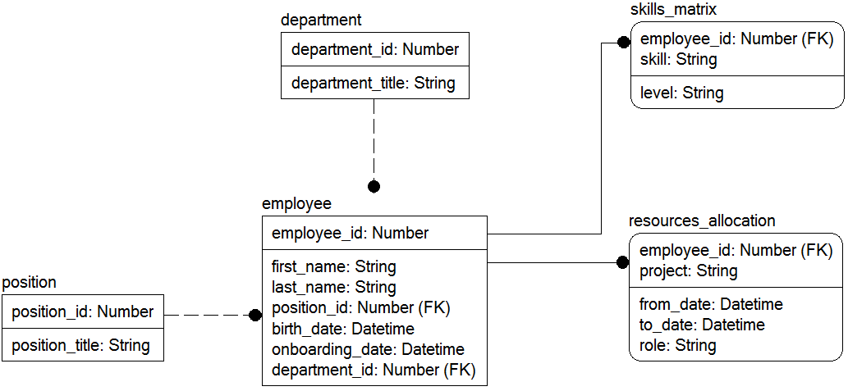

Modify the data model according to requirements below:

(result model must correspond to the 3NF)

1. Modify the data model to provide storing data about fired employees, considering the date and reason.

FN: ________________________________  Group: ____________

Date: ______________



Modify the data model according to requirements below:

(result model must correspond to the 3NF)

2. Modify the data model to provide storing data about working periods, considering the position and payment per hour in each period.

FN: ________________________________  Group: ____________

Date: ______________



Modify the data model according to requirements below:

(result model must correspond to the 3NF)

3. Modify the data model to provide storing data about vacation days, considering available and used days per specific year.

FN: ________________________________  Group: ____________

Date: ______________



Modify the data model according to requirements below:

(result model must correspond to the 3NF)

4. Modify the data model to provide storing data about sick leaves, considering the number of days and confirmation (sick leave document).

FN: ________________________________  Group: ____________

Date: ______________



Modify the data model according to requirements below:

(result model must correspond to the 3NF)

5. Modify the data model to provide storing data about working hours of employees for each working day (specific dates).

FN: ________________________________  Group: ____________

Date: ______________



Modify the data model according to requirements below:

(result model must correspond to the 3NF)

6. Modify the data model to provide storing data about previous employee’s positions, considering working periods for each position.

FN: ________________________________  Group: ____________

Date: ______________



Modify the data model according to requirements below:

(result model must correspond to the 3NF)

7. Modify the data model to provide relation between each employee’s position and department, considering working periods.

FN: ________________________________  Group: ____________

Date: ______________



Modify the data model according to requirements below:

(result model must correspond to the 3NF)

8. Modify the data model to provide storing data about sub-departments for each department.

FN: ________________________________  Group: ____________

Date: ______________



Modify the data model according to requirements below:

(result model must correspond to the 3NF)

9. Modify the data model to provide storing data about skills required for a certain position, considering the level for each skill.

FN: ________________________________  Group: ____________

Date: ______________



Modify the data model according to requirements below:

(result model must correspond to the 3NF)

10. Modify the data model to provide storing data about levels of employee’s skills.

FN: ________________________________  Group: ____________

Date: ______________



Modify the data model according to requirements below:

(result model must correspond to the 3NF)

11. Modify the data model to provide storing data about skills required for a certain role in a project.

FN: ________________________________  Group: ____________

Date: ______________



Modify the data model according to requirements below:

(result model must correspond to the 3NF)

12. Modify the data model to provide storing data about required resources (roles) for each project, considering the payment per hour and deadline.

FN: ________________________________  Group: ____________

Date: ______________



Modify the data model according to requirements below:

(result model must correspond to the 3NF)

13. Modify the data model to provide storing data about project stages, considering the working period for each stage.

FN: ________________________________  Group: ____________

Date: ______________



Modify the data model according to requirements below:

(result model must correspond to the 3NF)

14. Modify the data model to provide storing data about requirements for each project, considering the type of requirement (functional, non-functional, etc.).

FN: ________________________________  Group: ____________

Date: ______________



Modify the data model according to requirements below:

(result model must correspond to the 3NF)

15. Modify the data model to provide storing data about project documentation (e.g., technical task) for each project, considering document format (text, spreadsheet, a certain CASE-tool format, etc.).

FN: ________________________________  Group: ____________

Date: ______________



Modify the data model according to requirements below:

(result model must correspond to the 3NF)

16. Modify the data model to provide storing data about technologies (programming languages, DMBS, etc.) used in each project, considering technologies types.

FN: ________________________________  Group: ____________

Date: ______________



Modify the data model according to requirements below:

(result model must correspond to the 3NF)

17. Modify the data model to provide storing data about tasks for each project, considering the priority and status of each task.

FN: ________________________________  Group: ____________

Date: ______________



Modify the data model according to requirements below:

(result model must correspond to the 3NF)

18. Modify the data model to provide storing data about countries of remote employees, considering a certain time zone.

FN: ________________________________  Group: ____________

Date: ______________



Modify the data model according to requirements below:

(result model must correspond to the 3NF)

19. Modify the data model to provide storing data about project customer’s representatives, considering the first name, last name, contacts, and position.

FN: ________________________________  Group: ____________

Date: ______________



Modify the data model according to requirements below:

(result model must correspond to the 3NF)

20. Modify the data model to provide storing data about customer’s staff, considering the position and role in a certain project.

FN: ________________________________  Group: ____________

Date: ______________



Modify the data model according to requirements below:

(result model must correspond to the 3NF)

21. Modify the data model to provide storing data about several email addresses of a project’s customer, considering the purpose of each address.

FN: ________________________________  Group: ____________

Date: ______________



Modify the data model according to requirements below:

(result model must correspond to the 3NF)

22. Modify the data model to provide storing data about several phone numbers of a project’s customer, considering the purpose of each number.

FN: ________________________________  Group: ____________

Date: ______________



Modify the data model according to requirements below:

(result model must correspond to the 3NF)

23. Modify the data model to provide storing data about several Skype accounts of a project’s customer, considering the purpose of each number.

FN: ________________________________  Group: ____________

Date: ______________



Modify the data model according to requirements below:

(result model must correspond to the 3NF)

24. Modify the data model to provide storing data about legal status of each project’s customer, considering is it private person or legal entity.

FN: ________________________________  Group: ____________

Date: ______________



Modify the data model according to requirements below:

(result model must correspond to the 3NF)

25. Modify the data model to provide storing data about possible payment options for each project’s customer, considering the corresponding account, e-wallet, etc.

FN: ________________________________  Group: ____________

Date: ______________



Modify the data model according to requirements below:

(result model must correspond to the 3NF)

26. Modify the data model to provide storing data about employee’s working contacts – several phone numbers.

FN: ________________________________  Group: ____________

Date: ______________



Modify the data model according to requirements below:

(result model must correspond to the 3NF)

27. Modify the data model to provide storing data about employee’s working contacts – several email addresses.

FN: ________________________________  Group: ____________

Date: ______________



Modify the data model according to requirements below:

(result model must correspond to the 3NF)

28. Modify the data model to provide storing data about employee’s working contacts – several Skype accounts.

FN: ________________________________  Group: ____________

Date: ______________



Modify the data model according to requirements below:

(result model must correspond to the 3NF)

29. Modify the data model to provide storing data about personal phone numbers for each employee.

FN: ________________________________  Group: ____________

Date: ______________



Modify the data model according to requirements below:

(result model must correspond to the 3NF)

30. Modify the data model to provide storing data about home address for each employee.

FN: ________________________________  Group: ____________

Date: ______________



Modify the data model according to requirements below:

(result model must correspond to the 3NF)

31. Modify the data model to provide storing data about family members of each employee, considering the full name, birth date, and relation type.

FN: ________________________________  Group: ____________

Date: ______________



Modify the data model according to requirements below:

(result model must correspond to the 3NF)

32. Modify the data model to provide storing data about higher education of employees, considering the university, specialty, year of graduation, and number of diploma.

FN: ________________________________  Group: ____________

Date: ______________



Modify the data model according to requirements below:

(result model must correspond to the 3NF)

33. Modify the data model to provide storing data about various documents (diploma, certificate, etc.) that proof employee’s skills, considering dates of issue.

FN: ________________________________  Group: ____________

Date: ______________



Modify the data model according to requirements below:

(result model must correspond to the 3NF)

34. Modify the data model to provide storing data about employee’s language skills, considering fluency levels in each language.

FN: ________________________________  Group: ____________

Date: ______________



Modify the data model according to requirements below:

(result model must correspond to the 3NF)

35. Modify the data model to provide storing data about employee’s personal cars, considering the brand, model, year, engine type, number of passenger seats, and number of parking spot.

FN: ________________________________  Group: ____________

Date: ______________



Modify the data model according to requirements below:

(result model must correspond to the 3NF)

36. Modify the data model to provide storing data about employee’s absence, considering the reasons of absence.

FN: ________________________________  Group: ____________

Date: ______________



Modify the data model according to requirements below:

(result model must correspond to the 3NF)

37. Modify the data model to provide storing data about employee’s hobbies.

FN: ________________________________  Group: ____________

Date: ______________



Modify the data model according to requirements below:

(result model must correspond to the 3NF)

38. Modify the data model to provide storing data about anthropometric data for each employee (height, weight, clothes size, foot size, etc.).

FN: ________________________________  Group: ____________

Date: ______________



Modify the data model according to requirements below:

(result model must correspond to the 3NF)

39. Modify the data model to provide storing data about employee’s work devices (laptops, mobile devices, headphones, etc.).

FN: ________________________________  Group: ____________

Date: ______________



Modify the data model according to requirements below:

(result model must correspond to the 3NF)

40. Modify the data model to provide storing data about employee’s vacations, considering the leaving period, as well as the vacation type (paid, unpaid, etc.).

FN: ________________________________  Group: ____________

Date: ______________



Modify the data model according to requirements below:

(result model must correspond to the 3NF)

41. Modify the data model to provide storing data about employee’s education, considering education institution, period, education level (basic, high school, professional school, higher education, etc.).

FN: ________________________________  Group: ____________

Date: ______________



Modify the data model according to requirements below:

(result model must correspond to the 3NF)

42. Modify the data model to provide storing data about types of employment for each employee (staff, part-time, contractor, etc.).

FN: ________________________________  Group: ____________

Date: ______________



Modify the data model according to requirements below:

(result model must correspond to the 3NF)

43. Modify the data model to provide storing data about sport achievements of employees, considering the sport, rank, and date of issue.

FN: ________________________________  Group: ____________

Date: ______________



Modify the data model according to requirements below:

(result model must correspond to the 3NF)

44. Modify the data model to provide storing data about employees’ membership in professional communities and associations.

FN: ________________________________  Group: ____________

Date: ______________



Modify the data model according to requirements below:

(result model must correspond to the 3NF)

45. Modify the data model to provide storing data about employees’ loans, considering loan period, amount, and payment.

FN: ________________________________  Group: ____________

Date: ______________



Modify the data model according to requirements below:

(result model must correspond to the 3NF)

46. Modify the data model to provide storing data about employees’ awards of different types (certificates, medals, cups, etc.).

FN: ________________________________  Group: ____________

Date: ______________



Modify the data model according to requirements below:

(result model must correspond to the 3NF)

47. Modify the data model to provide storing data about payment conditions for each customer (prepaid, postpaid, etc.).

FN: ________________________________  Group: ____________

Date: ______________



Modify the data model according to requirements below:

(result model must correspond to the 3NF)

48. Modify the data model to provide storing data about employees’ pets, considering the name, type, breed, age, and weight.

FN: ________________________________  Group: ____________

Date: ______________



Modify the data model according to requirements below:

(result model must correspond to the 3NF)

49. Modify the data model to provide storing data about employees’ food paid by organization, considering the type, ordered meals, and meal time.

FN: ________________________________  Group: ____________

Date: ______________



Modify the data model according to requirements below:

(result model must correspond to the 3NF)

50. Modify the data model to provide storing data about employees’ transportation paid by organization, considering the type, cost, number of rides per day.